Jason Clark

GAT211

Project 2

Maps Documentation

1. Intro to Map 1 (The Fearful Eye of Pan)

This map started out as a game project I started working on over the Winter break. In anticipation of taking GAT211 in the spring, I decided I might want to try to work on some games, especially those with maps that I could potentially use during the second project. It also came out of a desire to make a compelling linear, 1D map. The one I made the last semester was embarrassingly simple and really not in the spirit of the assignment at all. The creation of the basic framework of the map came before anything else. It started out as a pyramid of blocks that I thought I might continue to build off of, but decided to make an opposing one. Seeing that, I thought there might be a way to use four pyramids all facing in on each other. The next thing I thought about was what type of game might fit a map like this and for a reason I cannot adequately explain or even remember, I thought of the idea of a Panopticon, Jeremy Bentham’s famous prison design experiment in which there was one central guard tower surround by all the prisoner cells in a circle around it. The guards could see all prisoners, but the prisoners themselves would have no way of knowing if they were being watched at any given moment, thus causing them—at least so the theory goes—to act as if they are *always* being watched. The word “panopticon” can be broken down into two base words: “pan” meaning all-seeing and “optic” meaning eye—an all-seeing eye. The idea I took from this concept, then, was to try to make a game where the players felt like they could be thrown into battle at any given notice without forewarning.

The initial gameplay went something like this: players would move linearly along the pyramid of blocks towards the center of the board. After every player has made one move (by rolling a die and moving that many spaces forward), a four-pronged spinner in the middle would be spun—each prong tipped with an arrow—and when the spinner stopped, would point towards a line of squares on each player’s grid. If two or more players were currently on a square that the prongs pointed to, they would then be forced to fight. This was as far as I got in my original conception, the results of which can be seen in the picture above. I’ll now list the raw notes from the brainstorming session I had following this basic structure where I tried to flesh out the game a bit, giving it a system that would fit the map:

* Players start at the bottom right of their pyramids and move up towards the center, using a die roll (D4 maybe?)
* Would having the spinner move in a pre-determined format take away from the theme? Would it add any depth to the overall strategy that actually increased enjoyment? Probably not.
* If two or more players are in the “sight” of the eye at the end of the spin, they must fight. The loser(s) must go back to the start of their respective pyramids
* What about loot? Maybe a level up system? Dice upgrades? Battle avoidance?
* Certain tiles could have game-changing effects:
  + Upgrades and Downgrades of Dice
  + Switch direction of the eye (if moving in a pre-determined manner)
  + Gain fold for each row that is passed
  + One-time use benefits are granted that could be used in battle
* Hidden information? The theme is based on the panopticon so it would fit in well narratively speaking.
  + Players will not know where the eye will land until the end of each round when it is then spun.
  + Maybe look at the real models of panopticons for further inspiration here.
* Each different pyramid could be a different space/time period and the player plays as a warrior from a particular culture (Romans, Mongolians, Barbarians, Persians, etc…)
* “Loot” could also be based on the individual culture from whence the warrior comes.
* They are all trying to appease their own god, though this god is actually one “God”, Pan.

1. Map 1 (Fearful Eye of Pan) Lab Notes

Unfortunately, since I was gone on Monday, and misunderstood the directions Prof. Holcomb sent me in an email, I did not bring any prepared maps to the lab. It was only until we had joined up in groups that I took out my notepad, remembered I had made this map and game, and realized this was something I could use. Upon showing it to my group (Dakota Galayde and Maddie Santino) and explaining the basic concept behind, their first question was what kind of loot was I thinking about putting into the game. I had showed the basic framework that is pictured above and had only taken the most cursory of notes on what type of loot, if any, I might in the game. I did tell them I had been thinking of the idea of having players be able to buy better weapons and armor every time they were “killed” and sent back to the bottom of the pyramid. Dakota said he really liked the idea of giving such players a tail wind such as this and told me he thought it would definitely work to keep players engaged even if they have just been beaten. I told them about the idea of gaining currency and they both agreed having certain tiles laid out on the pyramids that give player’s gold would add some flavor to the map itself. While I might also want to give out some loot and/or gold after winning a battle, the details of that isn’t necessary for this particular assignment.

While I definitely wanted to give currency out to players using these grid tiles, I also thought gold alone might be a bit dry and decided to start thinking of some other things to add, either as other tiles or other choices when landing on certain “reward” tiles. The result of these thoughts turned into what I called the “Three G’s”:

* Gold – a currency used to buy armor and weapons when defeated in battle and sent back to the start
* Gift from the God – a boost to the player in battle, usually some one-off effect that can be used only on the next time that player fights
* Genuflection – The player character “worships” the God, bringing them further along the path. This would be some boost like jumping ahead a few spaces

I wasn’t sure if this would work best as a choice player’s would make when they landed on certain tiles or if it should be random. Again, this isn’t that important given this assignment, but for the sake of having something solid, I just decided to go with allowing player’s the choice of which of the three Gs they would take. And that sums up the work done on this first map, both in its creation, in lab, and its second iteration based on feedback after lab. This second iteration of the map, as drawn on large graph paper is presented here:

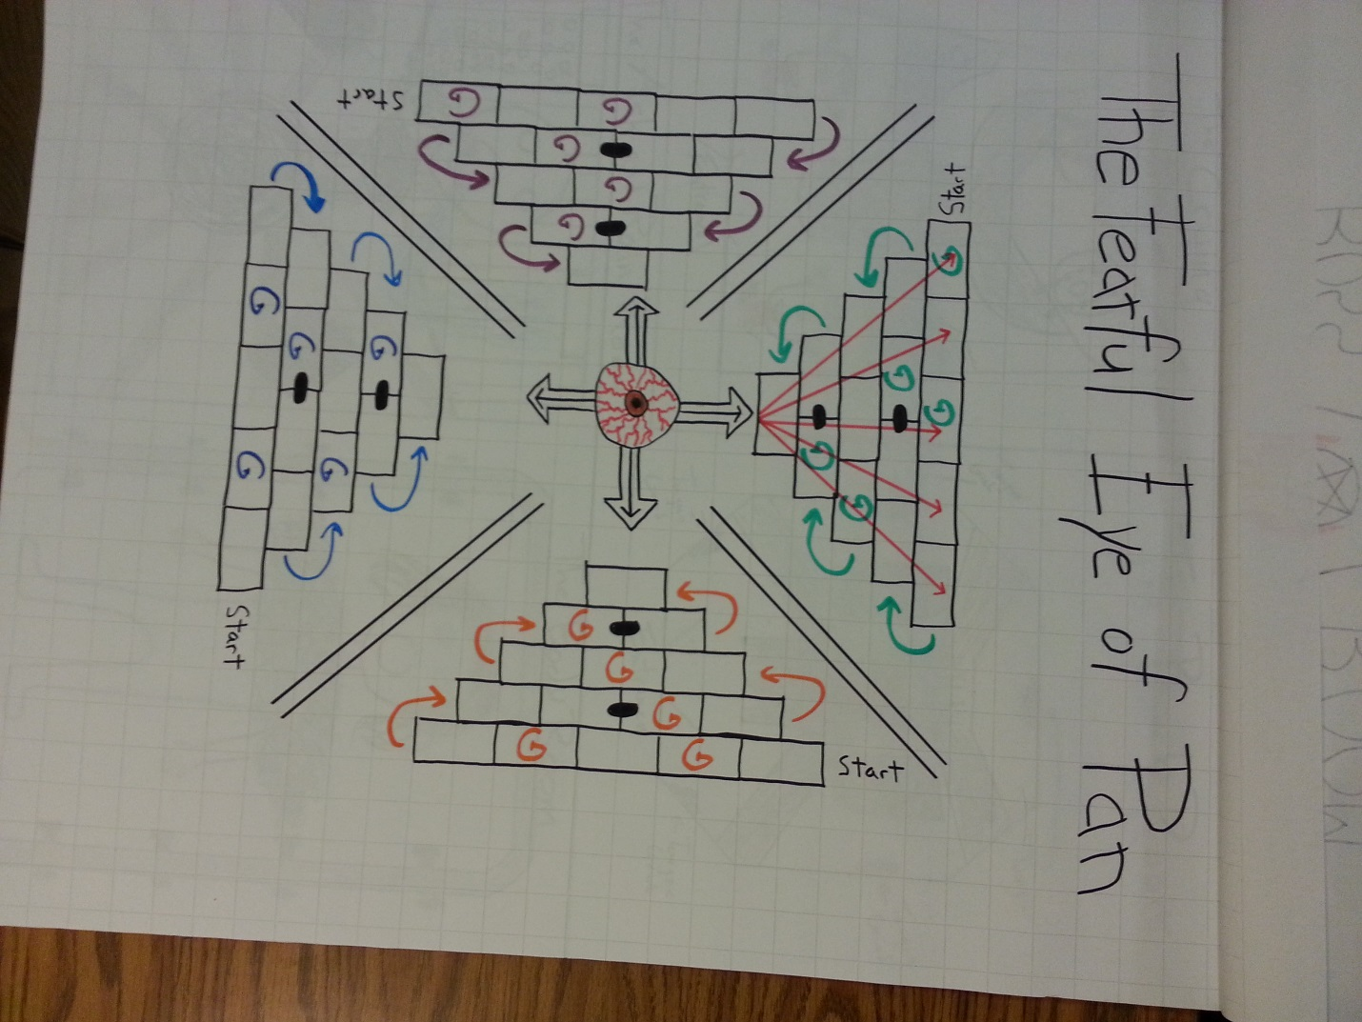

1. Map 1 (Fearful Eye of Pan) Intensity Curve with Up/Down Lists

Up/Down Lists

UP

* The initial spin after everyone has made their first move on the board. Happens around Time + 1:00.
* The first combat after everyone is settled (might actually be the second combat overall) and knows more or less what they’re doing. Happens around Time + 3:00 (especially if 2nd battle)
* Players getting into the groove of their particular game, gaining gifts and currency, making strategies, and so on. While not a big up at all (just .25 and then stays the same for two more minutes), it’s still not a down. Happens from Time + 4:00 – Time + 6:00.
* One player, either through a particularly tough battle—say where all four players fight, sending all but one player back to the start—or through gaining really great gear, starts to pull ahead of the rest, ratcheting up the tension. Happens at around Time + 7800.
* Other players start to make their last efforts either to gain some last momentum for themselves or to attempt to stop the lead player from making it to the end. Happens around Time + 9:00.
* The player in the lead is at the very last square and the final battle takes place. Happens at Time + 10:00.

DOWN

* Waiting for people to roll their die and move their spaces so the group can get to the spinning of the eye section. This happens every round so it’s a constant.
* After the initial excitement at the start of the game and realizing that most of the exciting parts won’t really happen until mid-game through the endgame. This is because getting knocked back to the start this early on isn’t nearly as big of a penalty as it will be later. This happens at around Time + 1:00 through Time +2:00
* Losing a battle and being pushed back to the start. Again, this is something that will happen any number of times during a game and can’t be pinpointed on the graph at happening at any particular time (except for say the first “real” battle at Time + 2:00 and the final battle at Time + 10:00).
* A good ways through the mid-game when the repetitiveness of the mechanics starts to sink a bit. In a longer game (and honestly, 10 minutes might have been a far too conservative guess at the time) this would be much more pronounced. Happens at around Time + 6:00 through Time + 7:00.
* The end after one player is crowned the victor and everyone reflects on their own game. Happens at Time + 11:00.

1. Intro to Map 2 (Setsuko: The Black Bunker)

The following maps are for a dungeon in a game called *Setsuko*. *Setsuko* is the game I’m working on as a member of Demon Parasol for GAM205 and GAM 255. The other members on the team are Eric Gleiser, Garrett Huxtable, and Travis Moore. As the Lead Designer for the game, I’m in the unique and serendipitous position of being able to work on my designs for the level maps in this class so that they might be even better when they are fully implemented in the engine. While I could document the entire creation process of *Setsuko*, it makes much more sense to just give a brief overview of the game and its mechanics providing a context for the maps themselves so that they might be better understood.

*Setsuko* is an action-adventure puzzle game in the same category of games like *The Legend of Zelda* and *Psychonauts*. The setting is immediate post-WWII Japan (in the late 1940s), somewhere in the countryside away from the major cities. The player takes of control of Setsuko, the hero of the game. She is a 12-year-old girl and the only child of her two loving, but battered parents. Her father, a solider during the war, is now crippled, having lost most of an arm and suffering severe nerve damage to his left leg due to shrapnel from a grenade. Her mother is a victim of radiation poisoning received from ubiquitous “black rain” that was everywhere around Hiroshima and Nagasaki after the nuclear blasts that occurred there. Black rain is what results when radioactive ash and dust that gets thrown up into the atmosphere mixes with rain. It turns into a black, radioactive sludge that falls everywhere and contaminates all who are exposed to it. Setsuko’s mother was one of those unfortunate people; her dose, sadly, is fatal.

As the game opens, Setsuko is sent by her father to see the famous Monk of the Mountains. He is their last hope for a cure. On the way, however, Setsuko falls through a rotten bridge into a river and is swept downstream to a woods she does not know. She soon finds hidden in the woods the grand and opulent palace of a yin-yang diviner, a sorcerer of sorts who has many great powers. After hearing her story, the diviner promises Setsuko that he will heal her mother as long as Setsuko retrieves three items for him: three relics of the original and most powerful yin-yang diviner in Japanese history, Abe no Seimei. This first relic lies within a dungeon not far from the diviner’s palace and it is this dungeon that is shown in the maps to be presented. Before she leaves his palace, however, Setsuko is given a very old parasol, or umbrella, that has become a *yokai* creature, gaining sentience and a personality of its own. It is through this yokai parasol that most of the game’s action mechanics emerge. This particular yokai—its common name in Japan is Kasa Obake—is known mostly for its long tongue, which can be seen in this picture, which was used as source material when we were designing him for our own uses:

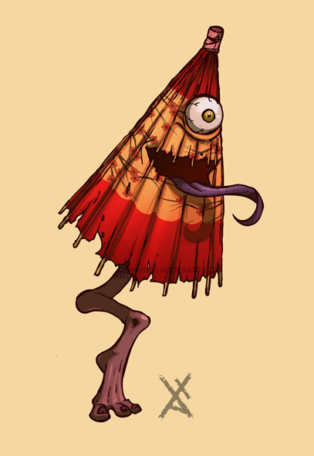

In this first dungeon, the one seen in the maps below, the mechanic based around the yokai’s long, elastic tongue will be featured the most; it finds use as a hook shot, allowing the player to both attach it to something then pull the player to it or to have it attach to an object and pull it back to the player. It can also be used to trigger otherwise unreachable switches or knobs.

Most of the environments in the game after the initial meeting with the diviner are being designed to reflect the internal and external damage caused by the nuclear bombs dropped on Hiroshima and Nagasaki. This first dungeon is thematically based around “black rain”: how it was created and how it affects the body. All of the “puzzle rooms” within the dungeon refer to some aspect of black rain whether it be the bombs that cause it to be made in the first place or the literal effect it has on the human body. While we are trying to keep everything within the bounds of E10, we are also considering talking to the faculty for permission to make a Teen rated game. Some of the effects of a nuclear blast, especially on a human body, are quite graphic and shocking. To tone them down would be disingenuous and, frankly, offensive. These bombs are terrible and they should be shown and known as the life and body destroying tools of war that they are. To do otherwise would be a disservice to all those affected by the bombs.

1. Map 2 (Setsuko: The Black Bunker) Discussion and Map Breakdown

The first map is both the entrance room of the dungeon as well as the “hub”, by which all other rooms are accessed. There are four “puzzle rooms”, each designated by one point of the five-pointed star in the middle of the room (the five-pointed star means something very, very different in Japan then it does in the West; it is the symbol of Abe no Seimei, the legendary yin-yang diviner and is also used to show all of the elements of the world are connected to each other). After each puzzle room is solved, the corresponding part of the star lights up in the color that is presented in the picture below. After all four of the puzzles are solved, the boss room door is finally opened allowing the player to go in and face the final boss. Before going any further, I’ll show the map of this HUB room here:

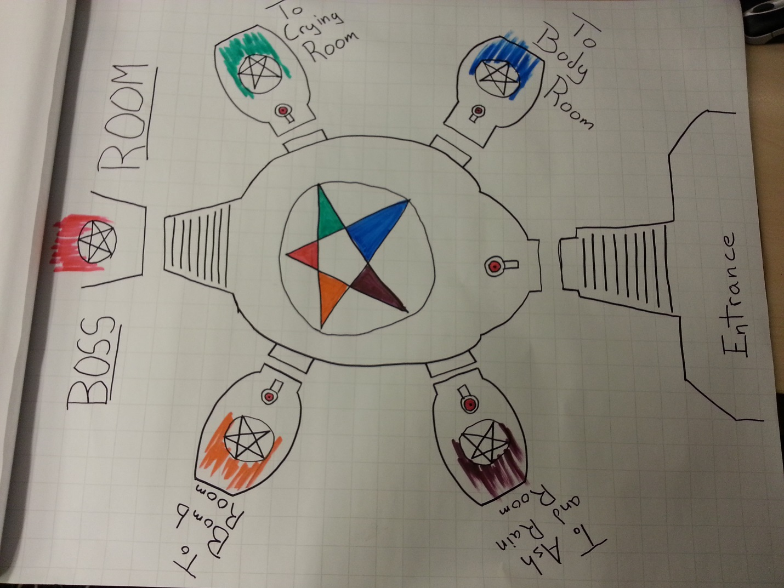

UP

@ Time + 0:00 – The player enters the dungeon. Hopefully, if we’ve done our job, the very entrance and first look at the main hall should be dramatic in itself.

@ Time + 2:00 – The player finishes one of the first rooms and one of the star points lights up, showing them that they have finished at least part of the dungeon and letting them know how to light up the rest.

@ Time + 6:00 – 8:00 – The player has lit up all four stars and when they reach the center of the room, the fifth, and final one, lights up, revealing the stairs to the Boss room above.

DOWN

@ Time + 2:00 – 6:00 – The player finishes two more rooms, lighting up two more of the points. While there is some progress noted, there is nothing new going on here and the player will probably just want to quickly get to the next puzzle room.

There is no particular order of rooms that the player must go in; they are allowed to choose any of the four from the moment they step into the dungeon. We wanted to keep this open approach so as to not place any undue weight on any one room and thematic context. They are all equally important and all part of the same revolting evil.

The first room I’ll present is what we’ve called the “Bomb Room”. In it, the player can move around to different parts of it by shooting the tongue of the yokai to the hooks on the wall and pulling themselves across. All the while, small nuclear bombs, purposefully designed after the “Fat Man”, one of the two nuclear bombs dropped on Hiroshima and Nagasaki (the other named “Little Boy”), emerge of the bomb bay doors and chase after the player, exploding on impact. The goal is to move into a position so that a bomb will hit one of the two columns in the room. When this happens, the column breaks in half, top half, falling into the black rain stream, both closing one half of the bomb bay doors and stopping up the stream of black rain.

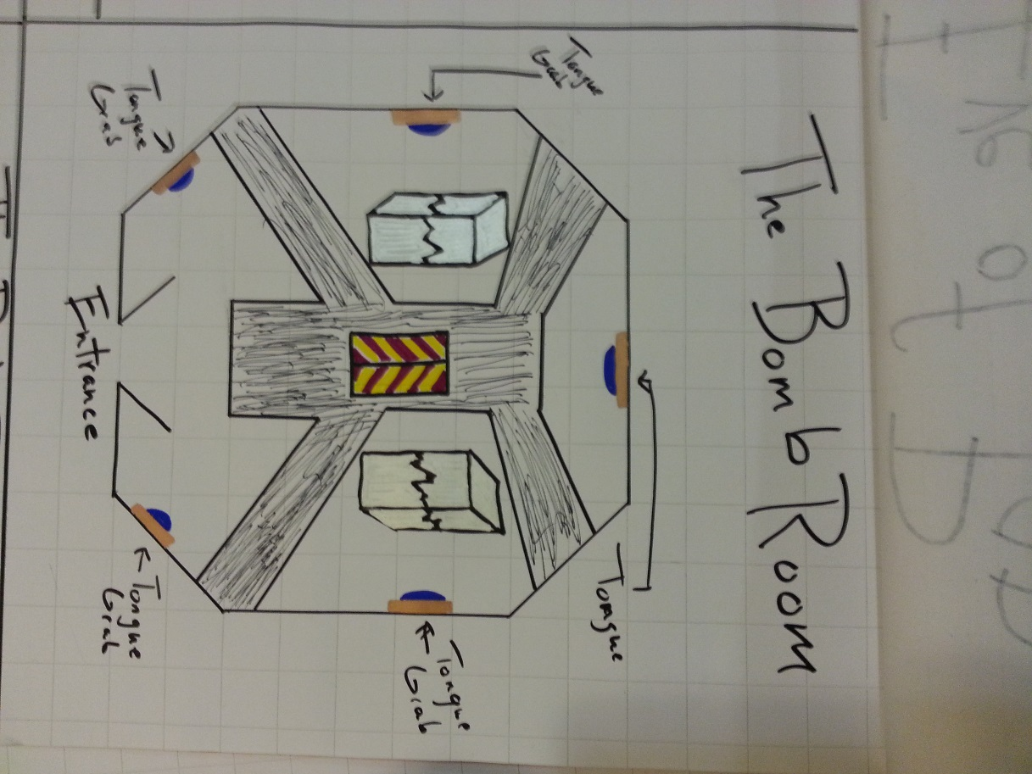

UP

Time + 0:00 – The player enters the room. To be honest, this is not the most exciting of rooms when one first walks into it. Thus there is a relatively low level of intensity at the start

Time + 0:30 – 1:00 – The bombs start to release, at first causing the player to panic and figure out how to block it. In running around avoiding them, however, the player will most likely either see the broken column and figure out that is what should be hit, or will accidentally have the bomb hit it while running away from it, revealing the solution.

Time + 2:00 – Seeing the room change once the black rain river running through it has been stopped up, signaling their completion of the dungeon

DOWN

Time + 1:00 – 1:45 – The player sees the solution and it is now just a matter of moving to the right place. The puzzle becomes trivial at this point (but that’s ok because it should only take a few more seconds to finish it)

The next room I’ll show is nicknamed “The Crying Room”. In this area, on the back two walls, there are two large faces, abstracted to look like masks, though both faces are clearly in the pain and agony. Out of the eyes of both faces runs tears of black rain, where they gather and collect in a pool below. The two pools connect and flow throughout the room. At the other side of the room, near the entrance, are two malicious yokai that have taken the form of fire-breathing traditional Japanese lanterns. They act as a barrier to the rest of the room. The player must perfectly time their movement to jump past the flames. Once they have moved past, the player must move to the small island of floor directly in front of one of two faces. Once there, they must use the tongue to grab the lantern and pull it back to them, immediately jumping back out of the way. Once there, the lantern will turn and breathe its fire on the face on the wall, leaving behind only a shadow, reminiscent of the “nuclear shadows” frozen forever on walls and streets by the intense light rays and blast of the nuclear bomb.

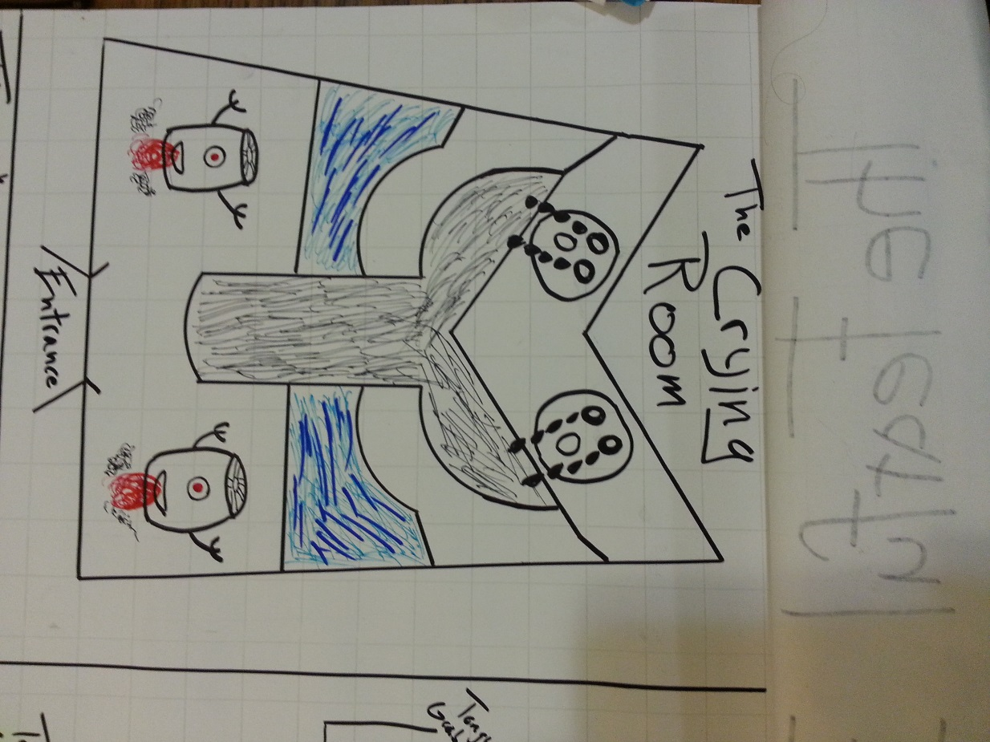

UP

@ Time + 0:00 – This room is a bit more visually arresting than the bomb room, with the two crying masks at the back, crying tears of black rain into puddles that form a small stream through the room.

@ Time + 0:30 – The player is challenged very quickly by the two lanterns blocking both paths into the room. They are rotating flames, causing the player to time their jump in order not to get hit.

@ Time + 1:30 – The player realizes the solution to the puzzle: they must grab the lanterns and pull them over to the platforms in front of the masks.

@ Time + 2:00 – The player finishes the puzzle room and sees the room change, letting them know it is complete.

The next room, nicknamed “The Ash and Rain Room”, is meant to show how the black rain is created in the first place. From two spouts at the ceiling, ash and rain water fall down into the room. Before they are allowed to hit the floor, however, they are are-directed by two large turbine propellers, modelled after the propellers from the airplane the *Enola Gay*, the bomber plane that dropped Fat Man and Little Boy on Hiroshima and Nagasaki. Both streams then go into the mouth of a mask situated on the back wall, where they combine and then fall to the floor as black rain. They then flow into a pool in the center of the room, with straight streams sending the black rain out of the room. The image of the pool and the streams evokes the Japanese flag during wartime. The player turn off each turbine and spout in a particular order. If the order is not followed correctly, various bad things happen, such as the room filling up with life-draining ash or the room filling with water causing the player to drown. All of these four things can be switched on and off with the yokai’s tongue.

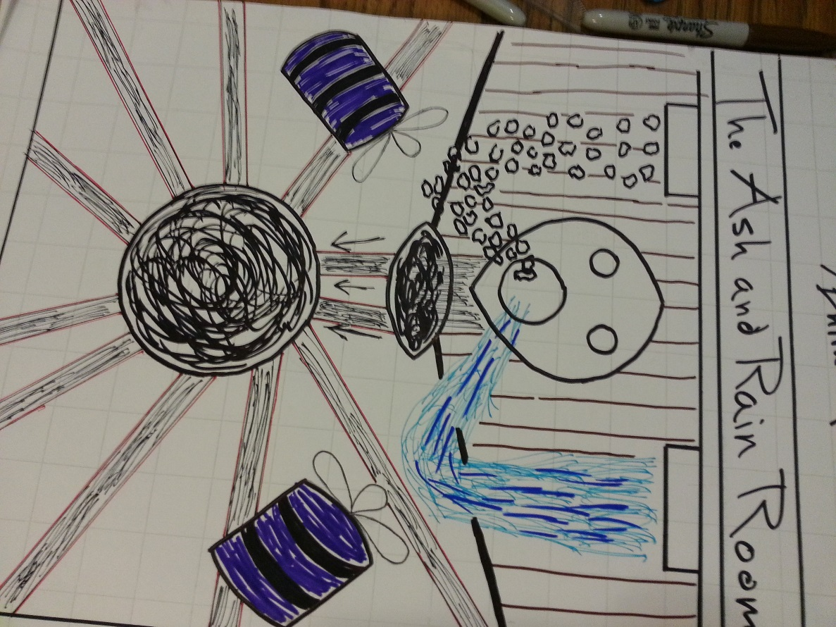

UP

@ Time + 0:00 – Probably the most visually arresting room in the dungeon upon first entrance, with the flow of water and ash as well as the two turbines at full power.

@Time + 1:00 – The player gets the first shock as they probably turn off the wrong part of the system, causing the room to attack them.

@ Time + 2:00 – The player figures out the right order, solving the puzzle, and seeing this room now change.

DOWN

@ Time + 0:30 – After seeing the room for the first time, it’s not immediately apparent what to do, leaving some players probably confused and slightly irritated.

@ Time + 1:30 – Trying to figure out the right order, especially if one has poor short term memory, could be quite annoying.

Finally, the fourth room, nicknamed “The Body Room”, demonstrates the effects of radioactive poisoning on the human body. This room is by far the most obvious in terms of what it symbolizes. As the designer, I wanted to make sure the players were at least aware of the most basic theme the game is trying to get across. Still, the body itself is very abstracted, save for the hair, denoting a female, referencing Setsuko’s mother who has been slowly dying from radiation poisoning received through black rain. This is a fairly easy puzzle to solve and involves merely turning off the various spouts on the pipes that run through the room, encircling a gigantic statue of a human body, as the pressure builds on each one, eventually causing them to explode and showing the body with black rain. Once the player has turned the wheel and stop the flow of black rain, that part of the body (there are four spouts on each side of the very large body that cover the, respectively, the head, upper torso, lower torso, and legs/feet) is then shown with different effects from radiation poisoning. The head has lost all of its hair and the mouth turns from a neutral grin to a cry of agony. The upper torso, which will have white circles moving through it in a pattern resembling circulation (and symbolizing the white blood cells within the body), will stop moving and have turned in a decayed, black stain on the body. The lower torso will be have various holes in it now, symbolizing the tumors, boils, and ulcerations that those affected with large doses of radiation suffer from. The legs and feet will take on flash burns, like those received by many of the people exposed to the intense light of the blast when it first hit.

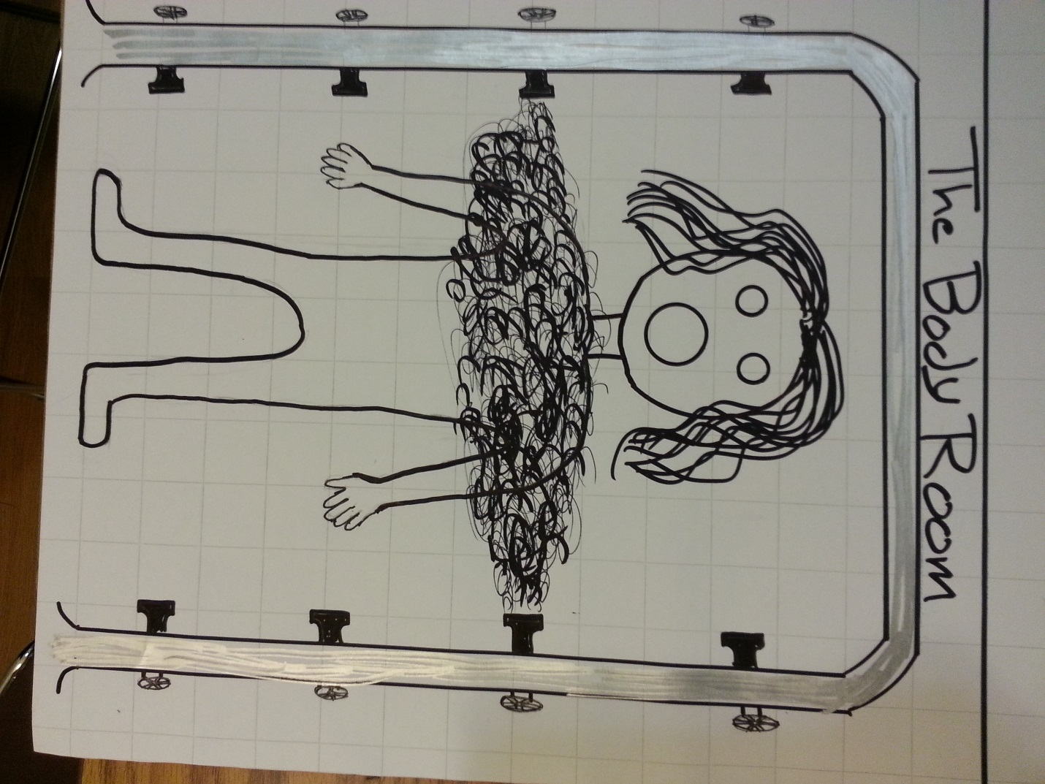

UP

@ Time + 0:00 – Another room that has a dramatic opening, as the player sees a gigantic bronze statue in the abstracted shape of human surrounded by pipework.

@ Time + 0:30 – 1:00 – The player sees the first build of pressure and then the explosion of black rain across the face of the body.

@ Time + 1:00 – 1:30 – The player sees the effect on the statue once the pressure has been relieved. It has changed dramatically to show the damage of the black rain, driving home the message of the room

DOWN

@ Time + 0:30 – After the initial first look at the room, it’s not immediately apparent what is to be done. The player’s patience might be taxed if we mistime the start of the puzzle while also giving the player enough time to get acquainted with the room.

@ Time + 2:00 – While not a big jump down, after the first shock of seeing the damage done to the statue’s head, it can only be slightly less exciting to see the results on the rest of the body, knowing already that there will be a change.

1. Intro to Map 3 (Ad Dominari)

The idea for this game and map (tentatively titled “Ad Dominari”, Latin for “Towards Domination”) came about when trying to think of what might work for a region map during the extra lab time had at the end of the lecture on Monday. I thought about using a place on the globe as a ready-made region and tried to think of what areas might make for an interesting game. The first place to pop in my mind was the Middle-East. Given the constant stream of news coming from that area over the past decades (and centuries really) it seemed like a suitable environment. What type of game then did it lend itself to? There could be the easy choice of making a barely-disguised *Risk* clone, but I felt that would be a disservice to that area. After about 30 minutes of thought off and on throughout the rest of the day I had settled on making a map for an “alien” world that had political strife similar to that seen in the Middle East. In this way I could try to make an original map while also taking myself out of potentially hazardous territory—a white, American male making overgeneralized comments about the Middle East seems a tad distasteful—but still invoking some of these real-world problems in an abstracted form.

I decided there would be three main factors in play in this game: culture, natural resources, and religion. While this sounds like a potentially troubling set of themes to be using for a board game, especially one in which I’m only supposed to come up with a very simple rule set, if one at all, I couldn’t really stop myself at this point. I also knew that the way I would use religion would be to abstract it as far as possible from any real-world comparisons. I started first by coming up with a resource that players would need to expand themselves across the map. I came with the world Proelium—based on the Latin word for fight—and made certain regions of the map give out more of this resource than the others. Given the map I had already made (see below), I decided the three centrally placed islands the locations that would give the biggest bonus. Players on both sides of the map could try to hold on to them to gain more of the resource, but are also open to attack from both sides.

I then started to think about where I would want players to start. I thought of a number of different ideas before realizing I may be going too deep into this one aspect and just decided that one player would start in a region on the west side, while the other would start on the east side. I realized I was turning too much towards the rules and away from the map, so I then decided how each region would affect the player trying to inhabit it. I decided on making three different “cultures” that are the natural inhabitants of the land (I had come up with some flimsy backstory about two competing, colonizing forces that both want to strip the planet of its natural resources; in other words, the clichéd, extremely liberal, sci-fi type stuff I default to when I can’t think of anything better). These cultures would be defined by how aggressive they were and paired up with names also created from Latin root words: The Bellitor are openly hostile; the Quietus are pacifistic; the Medius are neutral (that is, they have no problems defending or attacking if it’s in their best interests). These cultures would carry an attribute that would make them more or less willing to engage in conflicts with their neighbors, something the players would wish to manipulate as they try to gain control of the world.

At the beginning of the game, players can only inhabit up to two regions at any given time, but they are not bound by cultures. These are manipulative, technologically superior aliens playing politics behind the scenes. By accruing Proelium, however, players can expand and create new technology to help them wage war against their neighbors and eventually the other player. The three central islands—the ones with the Proelium bonuses—would be uninhabited and had no cultural attributes. Every other region besides these three central ones would give 1 Proelium resource per round. Players must also take into consideration the aggression attribute for each region they’ve taken control of. This will affect how successful they are in battle against other regions. For example, the Quietus will only give their full support of force if their “holy land” is invaded (the holy land is explained in the next paragraph), while the Bellitor actually decrease in efficiency the longer they are forced to wait before attacking. There would also be rules dictating what happens when one culture defeats another, and how that region is reassigned. Again, the systems that would control such a scheme are far beyond this assignment, but I thought it was, at the very least, an interesting setup for some potential, future game.

The last part of this game—at the least the last part that I thought of—was the inclusion of religion and “holy lands”. I thought of a rule where if players occupied the same region for more than 3 consecutive turns, that region would then house a holy land for that culture. When holy lands do arise they dramatically alter the allegiances of the population. There can only be three holy lands in any one game and they occur in the regions where one of the two players stays for more than three consecutive turns. Only time this happens for a particular *culture* (the Bellitors, Quietus, and Medius) it cannot happen again. This changes the game by having all the other regions on the map where that culture exists now wishes to actively keep the holy land within that culture’s particular. And it was at this point in my development of the game (a good two hours spent in deliberation) that I realized I had gone way too far and needed to stop. Hopefully I had not gone too far out of the bounds of the assignment and had created a map that could potentially be a first pass for a game of this style.

1. Map 2 (Ad Dominari) Scan

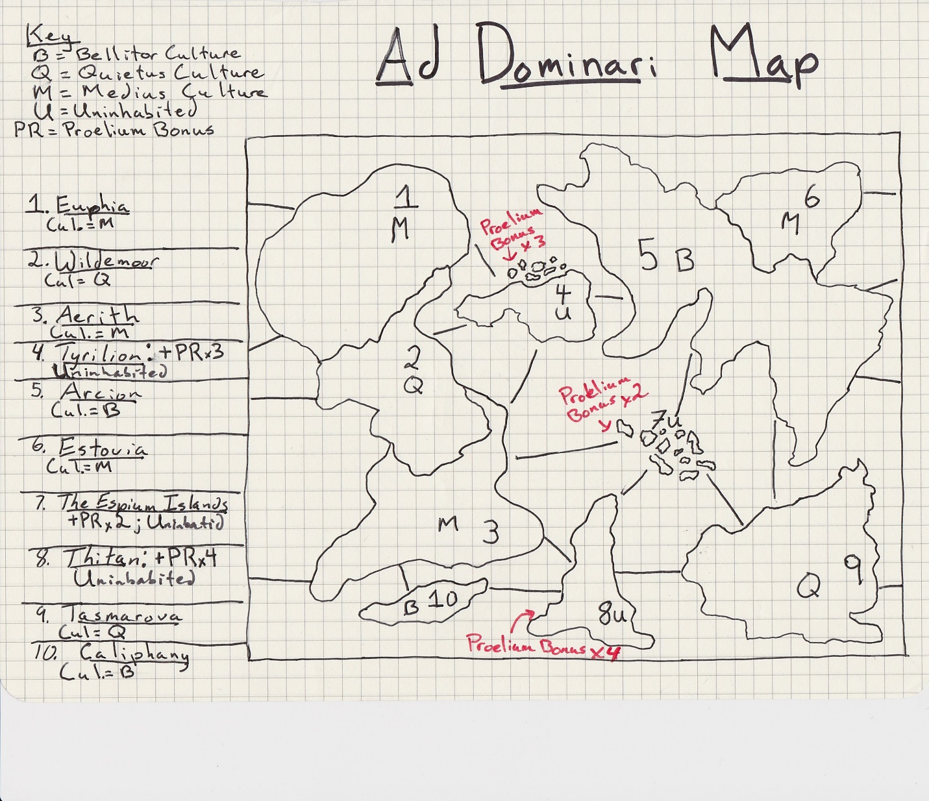

1. Map 3 (Ad Dominari) Intensity Curve with Up/Down Lists

UP

@ Time + 1:00 – 4:00: Players are getting set up and starting on their first initial moves. There is excitement caused by playing someone either new or someone you’ve had a rivalry with. This is a game about domination and strategy, so opening moves will most likely be very important in terms of one’s own strategy and figuring out how your competitor is planning to play.

@ Time + 12:00 – 16:00: After both players have become more comfortable on their respectable sides of the map, one of the players must eventually make a move towards the central islands or to attack the other player (if they have regions close enough at this point). Also, the first holy land is created, whether intentionally or because a player merely forgot about it, changing the dynamics of the game.

@ Time + 20:00 – 24:00: Both players have made clear their strategy and now they are refocusing their strategies to respond to the state of the board. The other two holy lands have now been “discovered” and are either aiding or hurting the player who has control of that region.

@ Time + 28:00 – 36:00: A continual climb as the game reaches its climax with one or the other player making moves or mistakes that can change the sway of power on the board back and forth. This could come from players over-reaching themselves or being too conservative or even getting an unexpected tailwind due to the other player forgetting about certain regional attributes.

DOWN

@ Time 4:00 – 8:00: Players have seen the opening moves of the other player and gets a bit comfortable in the opening play, making rote decisions without committing to one action yet.

@ Time 8:00 – 12:00: Players are now getting a bit more of a foothold on the map but are perhaps too hesitant to make a big move, in case they have missed something the other player is planning. I’ve personally seen this hesitancy happen more often in the completely strategic type of games this is trying to be.

@ Time 16:00 – 20:00: Players settle back down after the first big movements on the board.

@ Time 24:00 – 28:00: Some hesitancy again as it is clear the game is starting to move towards a point of no return. This can cause an “analysis paralysis” if there are too many rules/attributes at play, something this game could very well lead to.

1. Intro to Map 4 (Persona Q)

This map is for the game *Persona Q* (exclusive to the Nintendo 3DS, the most recent in a long series of JRPGs made by the development studio Atlus (*sic.*). It combines the narrative and combat from the Persona game series with the map and puzzle mechanics from the Etrian Odyssey game series (also developed by Atlus). Players move a party around a two-dimensional, square grid-based map, moving one grid at a time. Players can in any of the four directions on the grid as long as they are not blocked by obstacles or walls. There is a color indicator that shows how likely one is to be attacked by a monster at random. It goes from blue to green, to yellow, to red, changing from color to color after a certain amount of grid steps are taken. Monsters only attack during the red stage, but it’s still nice that the designers forecast the potential battle period in which the player must be ready so far ahead of time. There are also other monsters that are not random and which are clearly visible on the map. These are called “F.O.E.s” and are meant to be so hard when the player first encounters them that they are basically moving obstacles for the player to avoid.

There are at least two dozen different environmental, map-based mechanics at work throughout the many levels of the game, with often three or four or sometimes more working at the same time on the same level. The difficulty of these puzzles increase steadily as the player progresses through the game. As mentioned in the above introduction, it became impossibly hard to create a map using more than two of these within a reasonable amount of time so I picked my favorite map mechanic as well as a few examples of the ubiquitous F.O.E. encounters. The mechanic I chose has the player navigating moving platforms, or gondolas. The trick with these platforms is that they only move forward in the direction from which the player walks on to it. That is, if the player approaches it from the “left” side (left in terms of the overall larger map), then the gondola will move the player left across an empty space until it hits a solid platform again, on which the player is then deposited. This mechanic is used so that players’ must figure out the correct way to move around an area so that they can approach the correct gondola from the correct direction in order to proceed to the next area. There are a number of instances where the player must use the same gondola, but approach it from a different direction, sometimes being forced to leave it behind, only to come back to it later on in the level. I thought these puzzles extremely well crafted, giving me a tremendous sense of accomplishment once I was able to figure it out, and have tried to create my own two puzzles based on my experiences in playing through the game.

The map below shows the entire map on a grid (pretty much exactly as it shown on the bottom screen of the Nintendo 3DS when playing the game), with certain grids showing a letter or number that corresponds to a key to the right of the map. There are also green lines and arrows showing the solution to the puzzle as well. I think I failed my initial goal with this map as well as it took me well over 2 ½ hours to come to the final version of this map, having created three iterations of it before I actually was able to get it right. My respect for the makers of the many maps in *Persona Q* has now multiplied based on my experience trying to create the simplest of puzzles using only two mechanics. I will comment more on the details of the puzzle itself in the discussion of the intensity curve below.

1. Map 4 (Persona Q) Scan

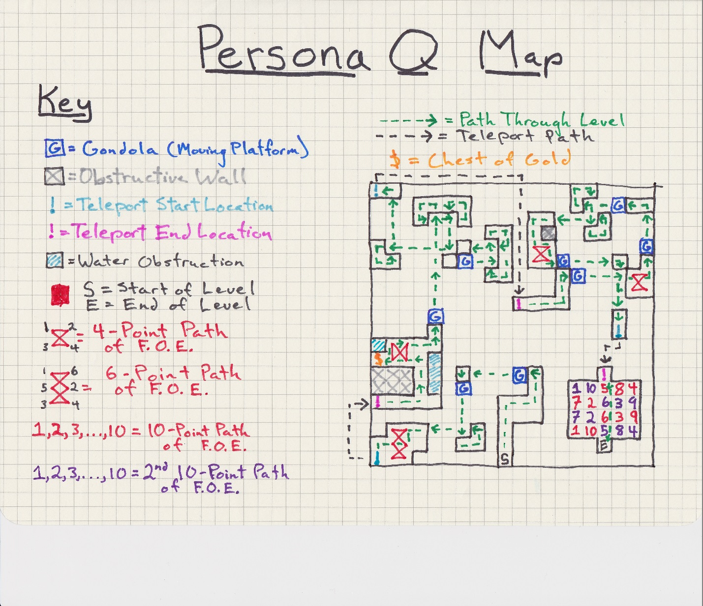

1. Map 4 (Persona Q) Intensity Curve and Up/Down Lists

UP

@ Time 0:00 – 1:00 – Player gets through the first area in the first 10 seconds and encounters this new, platform-moving mechanic. The first two gondolas are meant to show the player how they work (especially how to use one gondola more than once) but without being very difficult.

@ Time 2:00 – 3:00 – The player starts on the second set of gondolas, seeing that there are many more and that it will be an even greater challenge.

@Time 4:00 – 5:00 – The satisfaction of figuring out the puzzle and feeling the accomplishment of having finished the first half of the map.

@ Time 5:-00 – 6:00 – Immediately seeing there’s another gondola puzzle, the player being confident after the past experience that they are up to the challenge.

@ Time 8:00 – 9:00 – Finishing the second set of gondolas mixed with FOE monster/obstacles and feelings a sense of mastery over the level

@Time 10:00 – Feeling the accomplishment of having beaten the level and taken on a curveball with the two FOEs (there movement is staggered) at the very end.

DOWN

@ Time 1:00 – 2:00 – After seeing the gondolas, the player is given a short “break” where they face a simple FOE obstacle. This would have been something players have seen since the very first level of the game.

@ Time 3:00 – 4:00 – The player realizes the gondola puzzle is a bit trickier than expected—perhaps causing some frustration—being forced to leave behind one gondola in search of a way to come at from a different angle.

@ Time 6:00 – 7:00 – Similar to the frustrating moment in the first gondola puzzle where the player realizes they must now solve the puzzle while also dealing with FOEs, forcing them to correctly time their landing with the gondolas.

@ Time 8:00 – 9:00 – Thinking that at first this last part of the level is going to be easy and a bit of letdown, only to realize that it’s a completely different FOE pattern (and there’s now TWO of them) to navigate through to the end.

1. Intro to Map 5 (Setsuko: The Unscarred Lands)

This map was made as a result of needing to completely redo the opening of the game. As of the end of last semester, the opening portion of our game was made at different times without any real overriding design guiding its layout. It developed more out of the need to test technical issues for systems that we spent the majority of that semester building. Now that we had the tech out of the way, it was time to look back at the design and see what we could do with. I decided it would probably be best overall to just chuck the entire map made previously and start afresh so that there would be some coherence. As a group, we had also decided we wanted to work in the five stages of grief into the design. This is a story of a young girl coming to grips with the death of her mother and as such, we felt it might give the narrative more strength if we were able to include these stages, which most people are at least somewhat familiar if only having the knowledge that it is a concept.

With this in mind, I started to design the beginning section of the game (which would be split into five distinct sections corresponding to the stages of grief). The goal at this point in the game was not to get the player immediately into the mechanics of the game, but rather to give them a feel for the world they were about to traverse *as* a 11 or 12 year old Japanese girl who, up until now, has had a very surface-level experience with the world around her. I wanted that innocence to be the very first thing the player starts out with, knowing this is the first stage: Denial. So, from the beginning I designed Setsuko’s house in a cove backed up to a mountain and with rolling hills closing it off from the rest of the world. I wanted the player to feel like it was leaving an isolated haven where Setsuko has felt safe. (Note: As of right now, there will be a narrator who will deliver lines occasionally throughout this section and others giving information regarding Setsuko’s and her families past as well as their present concerns). She sets out seeking a famous Monk that she has heard stories about, determined that he will be able to help. Soon after leaving this isolated area, the player comes to a fork in the road, ostensibly allowing Setsuko her first choice. She can continue down the sunny path or try to head towards the more foreboding woods. As the woods will be blocked (and the narrator providing a simple explanation), the character will have no choice but to keep Setsuko on the bright and sunny path.

After she makes this choice, however, a light rain shower starts, symbolizing the first break in the illusion she’s set up for herself (that is, that she actually can cure her mother through magical means). The player soon comes to another fork, this time between the road to the city (where Setsuko might retrieve something practical that could ease her mother’s pain) or to continue down the path towards the monk. Again, the player will not actually have a choice and Setsuko will continue to go down the path towards the Monk. The thunderstorm get much worse this time as she quickly comes up to a bridge. This bridge symbolizes, both figuratively and literally, as the last chance to turn back and try things differently. Trapped in her state of denial even though the world itself seems to be telling her to stop, she crosses the bridge. Halfway across, it collapses taking her down a river and onto the rest of the game.

1. Map 5 (Setsuko: The Unscarred Lands) Scan

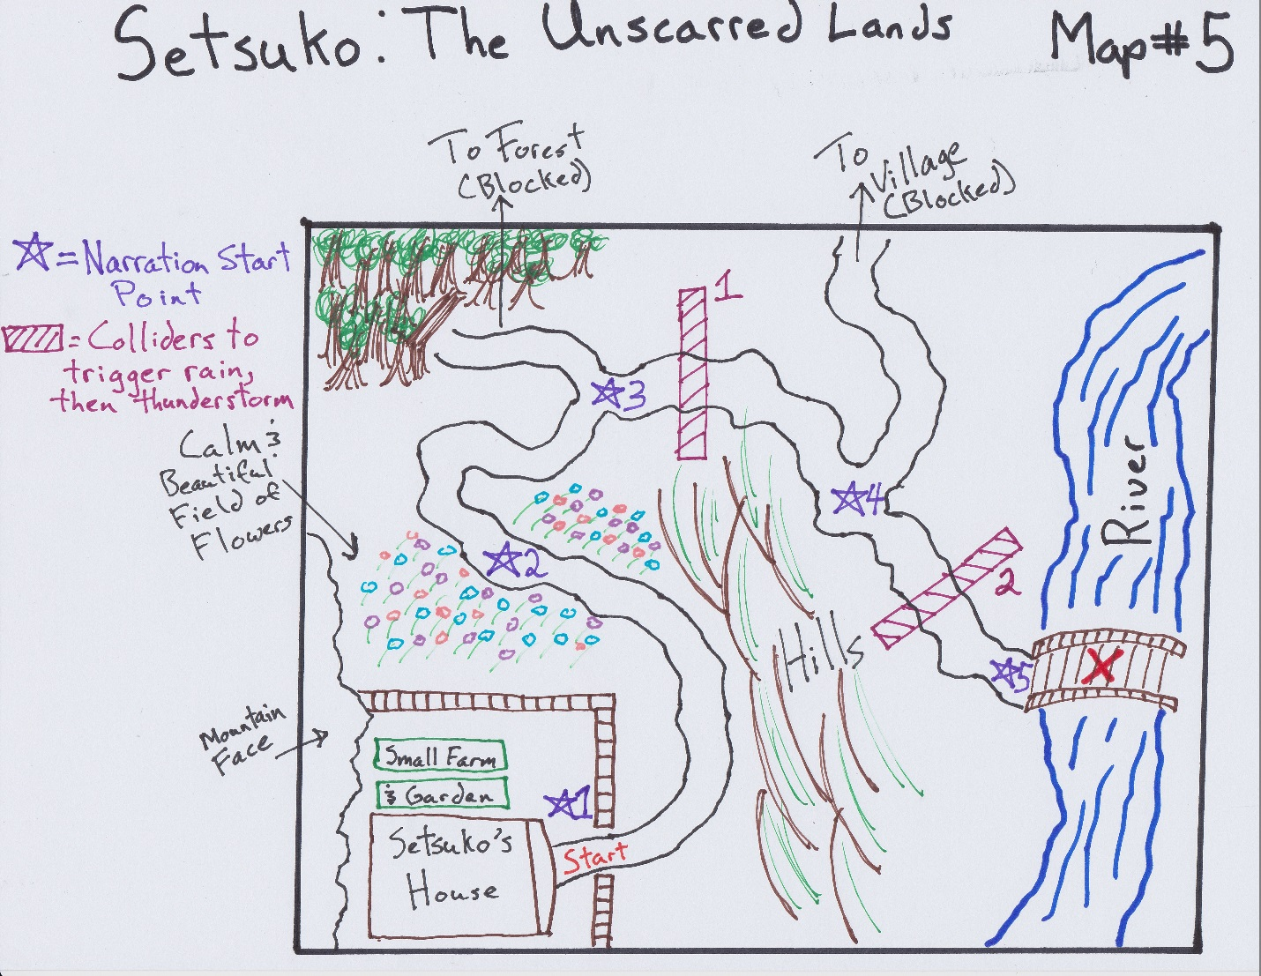

1. Map 5 (Setsuko: The Unscarred Lands) Intensity Curve and Up/Down Lists

UP

@ Time + 0:00 – 1:00 – The player starts out and walks through the front gate of the house and through the pleasant valley and fields of flowers, with interest climbing steadily but with no real spike or a moment of intense interest.

@ Time + 1:00 – 1:30 – The player hits the first fork in the road and realizes they can’t go down it. The narrator fills them in, ever so slightly, perhaps triggering some thoughts about why they can’t choose to go down a different path.

@ Time + 2:00 – 2:30 – The player hits the second fork and starts to see the pattern emerge. This girl has her mind set and she won’t be swayed. The player might now start to pick up on the overall theme of this area.

@ Time + 3:00 – 4:00 – The thunderstorm hits and the player realizes that they must keep going further down the same path. Hopefully through the symbols and the subtle narration it will now become clear what is going on. This segment then ends with an epic moment as lightning flashes, the camera shakes, and the bridge collapses sending Setsuko down the river.

DOWN

@ Time + 1:30 – 2:00 – The novelty of looking around this area has started to wane, causing the player to start actively looking around for more things to happen instead of just walking around.

@ Time + 2:30 – 3:00 – There is a change to a slight rain shower, but perhaps this underwhelming and it looks like the game might be just walking through landscapes with changing weather and a pointless narrator. Note: This part definitely needs playtesting.

1. Intro to Map 6 (Setsuko: Washed Up)

This is the section directly following the previous one (The Unscarred Lands). The player finds Setsuko washed up on the slight shore of the river before it empties into a foul swamp. The atmosphere is completely different from the location previous to this. As she rises to her feet, it’s obvious that her plan has completely gone off course and she is in slightly hostile territory. The player now has some slight control of Setsuko’s action besides walking: she can now punch the air. Not that this will do any good. The environment around her starts to attack as she moves along a barely visible path away from the river/swamp. An enlarged and carnivorous plants lashes out; a swarm of bees descend and chase her; carrion birds dive bomb her from above. She can try to swat at them with her fists, but it does no good at all. The player must run away if they are to survive. She is now in the stage of Anger, but despite all of her fury and indignation at her surroundings and circumstance, she is unable to do anything about it.

Not too far down this path, finally away from the attacking plant and animal life, she approaches a completely out-of-place palace in the middle of this swamp land. As she approaches, a voice calls out to her, entreating her to come inside and away from the creatures. There is a short cut-scene of sorts here where the player meets The Diviner, a character that promises to help Setsuko if she can locate two relics of a former, powerful Diviner. First, however, she must complete a small obstacle course so that he can be sure of her resolve and that she has the skills required. He equips with nothing but an old parasol and sends her out to another part of the swamp land. It is on this path that the parasol “wakes up”, informing Setsuko that it is a yokai (or “spirit demon”) that is under the thrall of the Diviner, forced to help him until he is released. This will be Setsuko’s primary method of interacting with her environment.

The next part of this area is the small obstacle course that is really just a tutorial for players to get used to moving around with the parasol grappling-hook tongue. It also has a simple puzzle using the parasol’s “wind push” ability. After she has finished the obstacle course, the path winds back around to another part of the palace where there is a small boat. The Diviner instructs her to get in and that it will take her to her first destination, The Black Bunker shown in Map 2 above.

1. Map 6 (Setsuko: Washed Up) Scene

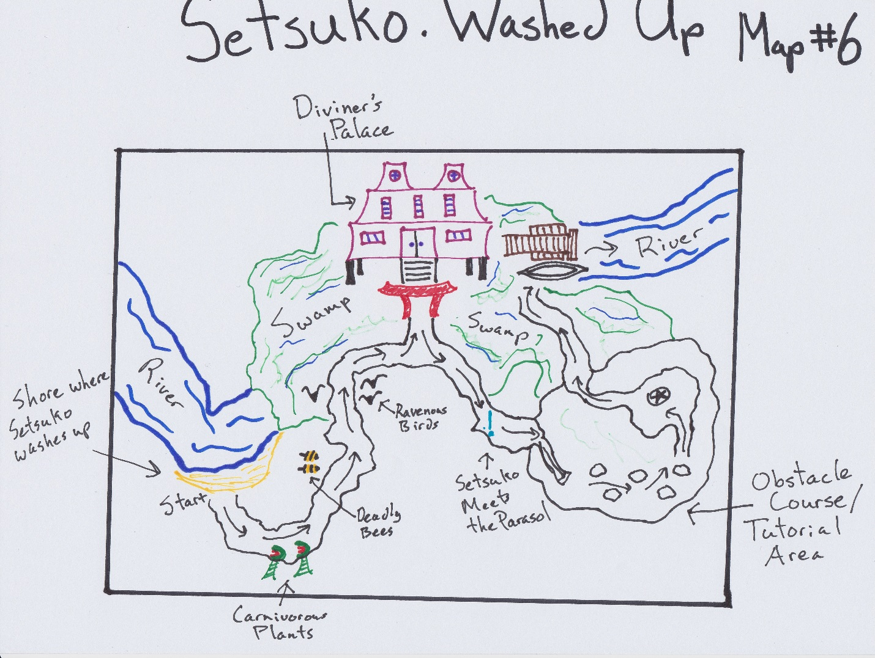

1. Map 6 (Setsuko: Washed Up) Intensity Curve with Up/Down Lists

UP

@ Time + 0:00 – 1:00 – The player washes up on the shore of a new area and discovers the use of Setsuko’s fist. Not terribly exciting, but a definite change of pace.

@ Time 1:00 – 3:00 – This is from the first encounter with the carnivorous plants, through the bees, and finally running away from the ravenous birds. The shock would first come because this is the first time the player has seen an enemy. The second, larger shock comes when the player realizes they can’t really fight back at all.

@ Time 5:00 – 6:00 – Meeting the parasol for the first time when it “wakes up”. Players who before might have thought an old umbrella was a lame weapon might now be pleasantly surprised at its new sentience.

@ Time 7:00 – 9:00 – First getting used to the basic grapple-hook method of jumping around areas using the parasol’s long, elastic tongue. Then moving immediately on to a puzzle using the parasol “wind push” ability giving the player a sense of accomplishment for learning the control scheme being able to move on to the first real dungeon awaiting them.

DOWN

@ Time + 3:00 – 5:00 – After the race from the deadly plant and animal life, the palace, while out of place, will still serve as a respite. As this is also a major plot point area, it has the potential to drag down players who are not at all interested in the plot.

@ Time + 6:00 – 7:00 – After the initial shock of meeting the umbrella, the player then has to figure out exactly how it is controlled. Figuring out controls, even at the beginning of a tutorial, is never a fun thing to do.